**Scenario:** Sandeep jain came to Infosys. He has given a 3 month contract to build G4G. 7 lakhs is allocated for development. 3 lakh is allocated for testing.

**STLC is a subset of SDLC**

Software testing life cycle is a process through which a software is tested to be bug-free. All the functional and non-functional requirements are tested here.

**Phases of STLC**

1. **Requirement analysis:** Understanding all the functional and non-functional requirements given by the client. Go through the documentation of the features to be developed.

**2.Test planning:** Test planning is

* analyzing the tools to be used

* Staffing needs if required.

* Training needs required.

*Time period of the testing.

* How much manual testing vs automation testing

* Features to be tested or not tested

*Risk Analysis

*Mitigation plan

**3. Test case development:**

Test case development is the process of writing test cases. A template is maintained. RTM is maintained. Requirements are mapped with test cases.

**4. Environment setup:** Environment setup includes tools, server requirements and any other hardware requirement require to run these test cases.

**5. Test execution**: Test execution is the process of running the test cases. If there is any bug found, it is reported. Reports of test cases passed/failed is maintained.

**6. Test closure:** All the bugs reported have been verified that are fixed . The testing cycle is closed.

**Writing test cases in excel sheet**

**Eg:** search box in bookmyshow. Below we are testing that even with excess space provided in input, suggestions should work fine.

**1.Testcase Id (unique):** Id given to a test case. It is always unique. Eg TC_01_search_space

**2. Requirement Id:** Requirement ID comes from the document given by the client. The test case is run against it. Ex: Req_01_search

**3. Test Case Scenario:** It is short description of the requirement which is being tested. Eg: testing search functionality. A test case scenario can have multiple test cases to it.

**4. Description :** Detailed functionality to be tested. Here the scenario is explained as what part of it is being tested in the test case. Eg: Even if the input contains spaces which are in excess the result of autosuggest should not change.

**5. Assumption & Precondition :** The pre-done steps to reach the test case is defined. Eg: The user is on the landing page.

**6. Input Test Data:** The data used to execute the test case. Eg: A V A T A R, AVATAR

**7. Test Case Execution Steps:** The steps required to run the test case are written here. Eg:

1. search box is clicked

2. input is provided

3. 2 second minimum wait is given

**8. Actual Result:** The result post executing the test case is recorded. Eg: Avatar movie was listed in the suggestion

**9. Expected Result:** The result that should come if the functionality is working fine. Eg: Movie name should be listed in the suggestion

**10. Test Case Status:** If the actual result matches the expected result. Status is passed else failed. Skip is also a test case status where for instance one functionality is being used in another. So, if the functionality is not working fine and is failed. The other case is skipped. Eg: A V A T A R still give avatar movie name in autosuggest. Status is Passed

**11. Defect Id:** If the test case fails , a bug is reported which goes through defect/ bug life cycle. A unique ID is provided which is called defect ID.

Eg: defect_01_search_space

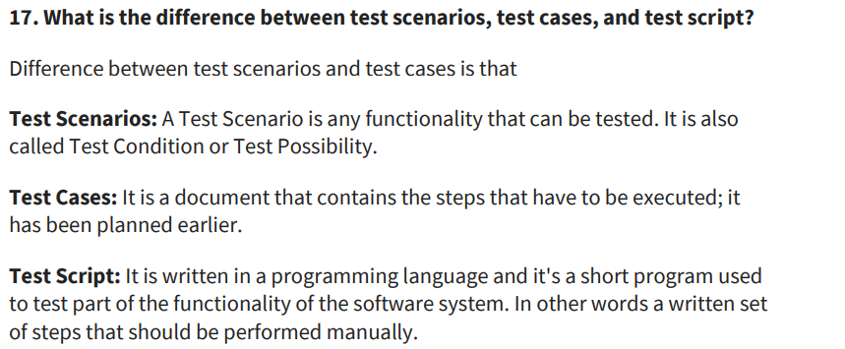

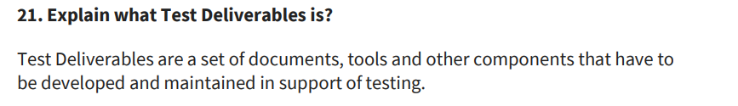

What does a test report contains

1. Date and time of testing

2. Tester name

3. Module tested

4. Test Cases Pass/Fail Percentage

5. Envionment

6. Test Objective

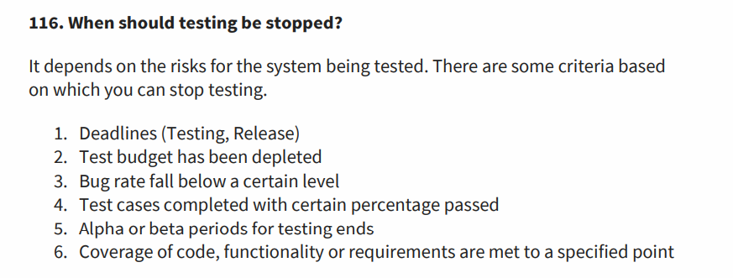

**Test coverage:** Test coverage is a quantitative measure of the number of functionalities that have been tested to that of the total functionalities developed in a software.

**What is test case:** Series of action taken to test a functionality is called a test case.

**What is test case scenario:** A brief description of the functionality being tested. Example: to check login functionality

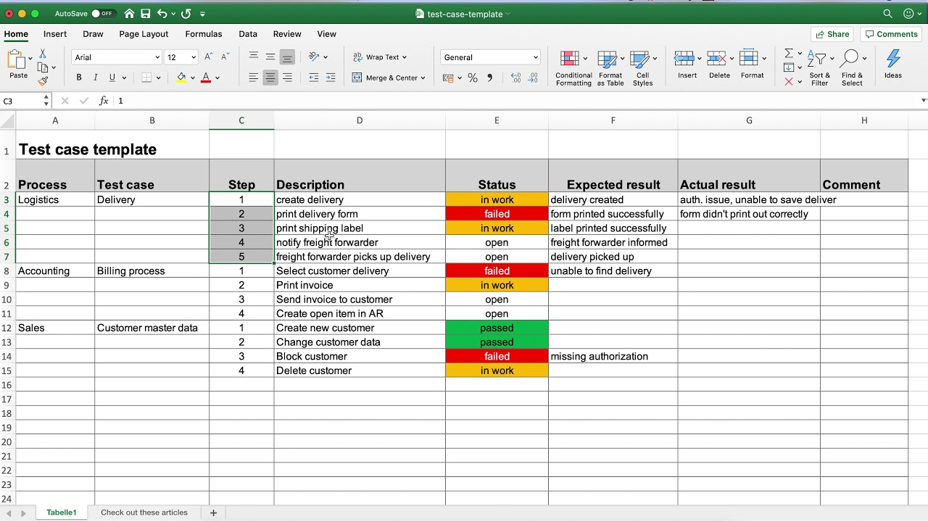

**What is a bug?**

Bug is state of program(code) which is not working as per the functionality of the software. For example- verification email link mailed twice (2) OTP is not being sent. (3) Screen is not scrollable and submit button hence cant be clicked(4) In linkedln, message is being sent and after sending chat box does not clear up.

**Bug vs Error Vs Defect**

Bug is a program which is not showing the expected result. Here my code is still working.

Error is when a piece or a program is not working. Example storage issue, file is corrupted, hardware error, input/output error, error to upload a file, server error in gpay.

Defect is generally used in manufacturing industry. Example if the is an iphone and screen is broken, or screen is having less brightness, or microphone is broken.

**Bug/Defect Life cycle:**

The different phases a bug goes through from the moment it is identified to getting it fixed is called a bug/defect life cycle.

Phases:

New state and open

Assigned to the developer

Developer would fix the bug

The tester would retest the functionality

On success the bug is closed

Else is sent back to the developer

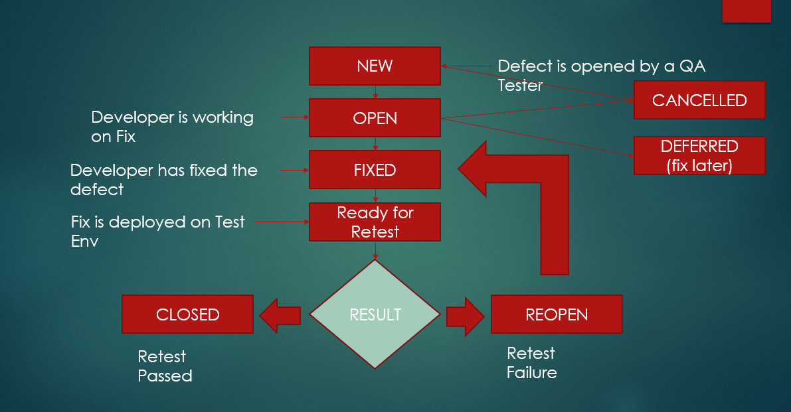

**Different bug states**

**New:** When a bug is reported.

**Open:** The tester is working on it as in to test what the bug is exactly

**Assigned:** When the bug is assigned to the developer to fix

**Fixed:** When developer says it is done from his side

**Pending retest**: When tester has to test the bug to close it

**Closed:** Finally the bug is closed after verification by the tester.

**Cancelled:** When the bug reported is indeed a feature of the application so bug is discarded by the testers.

**Deferred:** When the application contains bug but would be fixed in the next test cycle. So the bug we know would still go to the production.

**Reopen:** Bug was closed earlier by the tester. Some other issue was reported in the fixed code. So the bug is opened again.

**Duplicate:** The new bug reported has already been reported . So new bug is now in duplicate state.

**What is Priority:**

Priorityterm is used to tell the developer the urgency of the bug to deal with. Priority is categorized as High, Medium, Low. High priority bug must be resolved first.

**What is Severity:**

Severity term is used to emphasize on the business impact of the bug. The severity is categorized as Critical, Major, Medium and low.

**Defect template:**

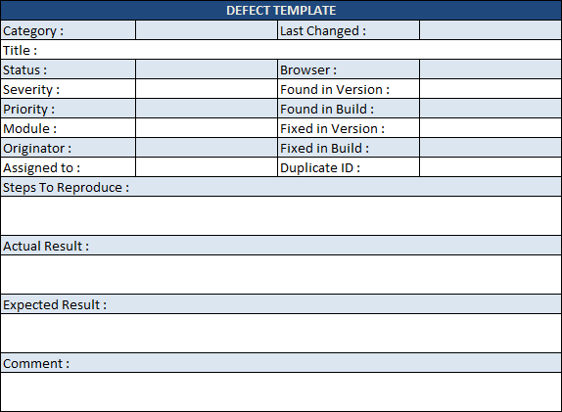

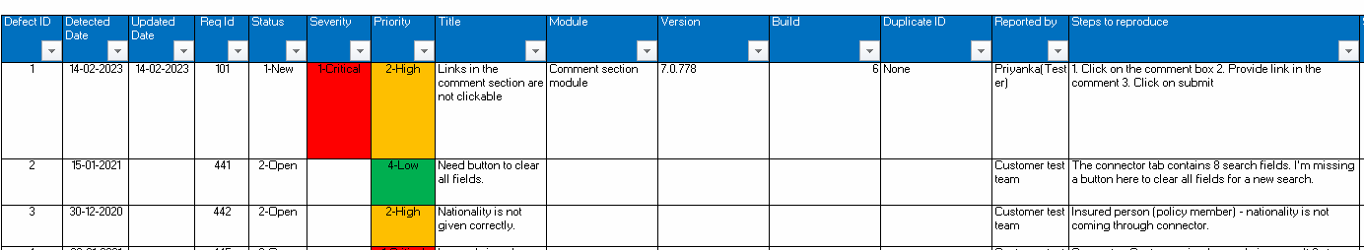

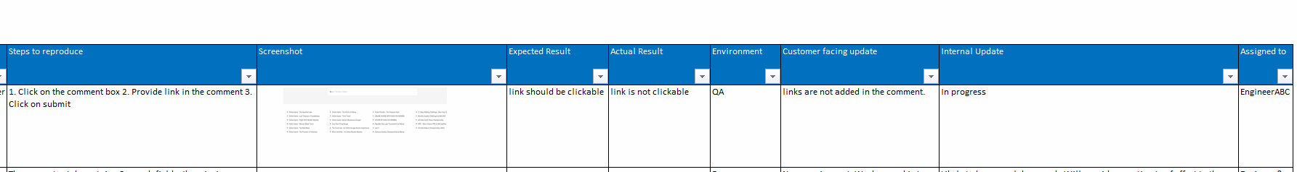

Defect id which comes from test report

Date of report

Bug status

Reported by

Title

module

Severity

Priority

Steps to reproduce

Expected result

Actual result

Screenshot

Assigned to

Duplicate id

|  |
| --- |
| Introduction to Test Case |
| • Test Case Design Techniques |
| o    Specification Based |
| o    Experienced Based |
| • Test Case Format |
| • Functional Test Case |
| • Integration Test Case |
| • System Testcase |
| • Test Strategy |
| • Procedure to Write and Execute Test Case |
| • Requirement traceability matrix(RTM) |
| • Test case Review Process |
|  |

Requirement Traceability matrix(RTM):

RTM is a grid which maps requirements with test cases.

|  |  |  |  |
| --- | --- | --- | --- |
| Req id | Req desc | Testcase id | Status |
| 1 | Test login functionality | Tc01  Tc02  Tc03 | Pass pass fail |
| 2 | Payment gateway integration | Tc04 tc05 tc06 | Pass pass pass |
|  |  |  |  |

To find the test coverage of the modules that is the extent with which a functionality has been tested.

**Test execution reports:** Test execution report lists down the activities done by the tester in a day for example test cases he run, defects he found etc.

**Test execution report contains:**

-Number of Test cases planned today

-number of test cases executed

-number of defects found

|  |  |  |  |  |  |
| --- | --- | --- | --- | --- | --- |
| Module name | No. of Tc written | No. of Tc executed | No. of Tc passed | No. of Tc failed | Pass% |
|  |  |  |  |  |  |
|  |  |  |  |  |  |
|  |  |  |  |  |  |
|  |  |  |  |  |  |
|  |  |  |  |  |  |
|  |  |  |  |  |  |

**Test case Review:** Before test cases are executed, the test lead does the test case review to ensure important test cases are not missed, test cases of higher business impact are tested first, which test data should be chosen

|  |  |  |  |  |  |
| --- | --- | --- | --- | --- | --- |
| Test case name | reviewer | comments | Tester comments |  |  |
| Tc_01 | Test lead ABC | Precondition is not mentioned | Done now |  |  |
|  |  |  |  |  |  |
|  |  |  |  |  |  |

**Specification Based Testing:**

Specification Based testing test the features/functionalities of the application. It is a black box testing technique. We can use boundary value analysis, equivalence class partitioning.

**Experienced Based Testing:**

Experienced based testing ensures the code is being written in a correct manner, the architecture and design are correct. Example: white box testing techniques like conditional flow, statement coverage, branch coverage.

**Test Strategy:**

Test Strategy in software testing is defined as a set of guiding principles that determines the test design & regulates how the software testing process will be done.

**Test planning vs test strategy:**

The approach to execute a test plan is called as test strategy that is what should be run first manual test cases or automation. Which functionalities should be tested first etc.